**HUMA 260 IN-CLASS Assignment**

Please answer the following questions in paragraph form:

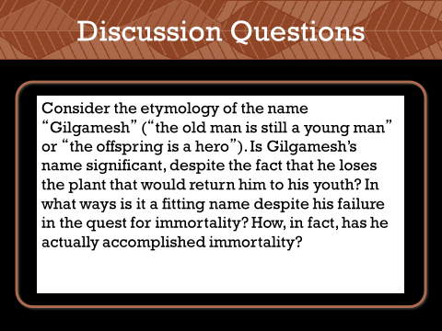

Yes, his name is significant, in the beginning of the story, he acts childish and believes it is his right to act however he wishes. In the end, he writes his story and thoughts into stone tablets and places them on the Uruk’s walls. It is implied that he gains immortality by being remembered by those who read his story.

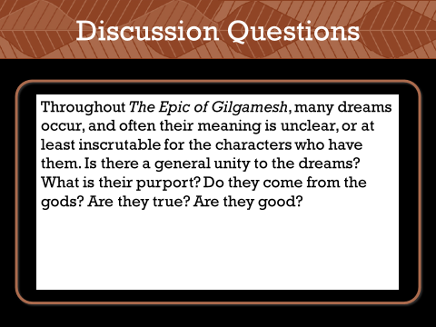

The dreams of the characters in the Epic of Gilgamesh are interpreted to be prophetic and as warnings of things to come.

The dreams probably do not originate from gods; in one instance, Enkidu dreams of the gods conspiring to kill him, something which the gods surely would not have wanted him to see.

The dreams are extremely vague, but what the characters interpret them as always comes true; via dreams, Enkidu is predicted to come, then does, Enkidu and Gilgamesh are predicted to slay Humbaba, they then do, etc.

The dreams are not always good; Enkidu dreamt that the gods conspired to kill him, then he actually fell ill and died.